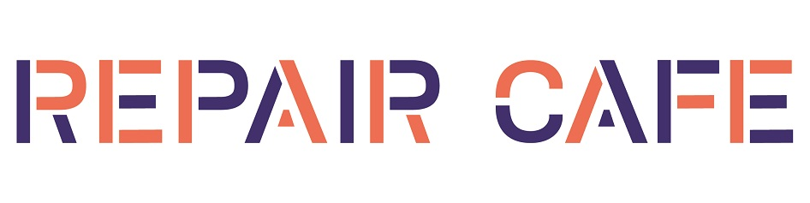
Kingston upon Thames

Repair Café is coming to Kingston Library Community Room on the 1st Saturday morning of every month, starting on 4th February 2023.

Repair Café Kingston is a community initiative, under the umbrella of Transition Town Kingston, promoting repair and skill-sharing as sustainable alternatives to throwing things away. Residents can bring their broken items to fix on the spot with the help of experienced volunteer repairers. All repairs and refreshments are free, though donations towards our costs are very welcome.

Find out more about the Repair Café or volunteering to fix things: see Transition Town Kingston’s website www.ttkingston.org/, or scan the QR code below, and/or come along to one of our Saturday morning sessions to meet us and have a chat.

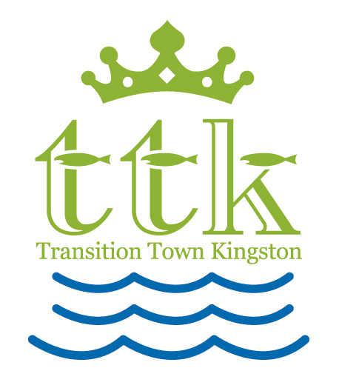

With thanks to Kingston Library for the space, and to John Lewis Kingston for seed-funding.

